**Tribhuvan University**

**Faculty of Humanities and Social Sciences**

**BLOOD BANK MANAGEMENT SYSTEM**

## A PROJECT REPORT

**Submitted to**

**Department of Computer Application**

**The Times International College**

***In partial fulfilment of the requirements for the bachelor’s in computer application***

Submitted by

*Name:* ***Nirmal Shrestha***

*Reg no.: 6-2-725-17-2018*

August 2022

Under the Supervision of

**Mr. Prasanga Regmi**



**Tribhuvan University**

**Faculty of Humanities and Social Sciences**

**The Times International College**

## SUPERVISOR’S RECOMMENDATION

I hereby recommend that this project prepared under my supervision by Nirmal Shrestha entitled **“**Blood Bank Management system**”** in partial fulfillment of the requirements for the degree of Bachelor of Computer Application is recommended for the final evaluation.

…………….

**SIGNATURE**

Prasanga Regmi

**SUPERVISOR**

Bachelor in Computer Application

Dilibazar, Kathmandu



**Tribhuvan University**

**Faculty of Humanities and Social Sciences**

**The Times International College**

## LETTER OF APPROVAL

This is to certify that this project prepared by Nirmal Shrestha entitled “**Blood Bank Management system**"in partial fulfillment of the requirements for the degree of Bachelor in Computer Application has been evaluated. In our opinion it is satisfactory in the scope and quality as a project for the required degree.

|  |  |
| --- | --- |
| **SIGNATURE of Supervisor**    Prasanga Regmi  Bachelor of computer application  Charkhal, Kathmandu | **SIGNATURE of HOD/ Coordinator**    Subash Belbase  Bachelor of computer application  Charkhal, Kathmandu |
| **SIGNATURE of Internal Examiner**  **Subash Belbase** | **SIGNATURE of External Examiner** |

ABSTRACT

‘Blood Bank Information System’ will be an information management system which helps to manage the records of donors and patients at a blood bank. The system will allow the authorized blood bank officer to login using a secret password and easily manage the records of the blood donors and the patients in need of blood.The key features of the system will be the following: Centralized database architecture. Access to the system secured by login. Search facility for finding blood donors based of various search criteria. Search facility for finding Patients (acceptors) based of various search criteria. Easy addition and updating of donor's details. Easy addition and updating of details of acceptors..

ACKNOWLEDGEMENT

We would like to express our deepest appreciation to all those who provided us with the possibility to complete this report. We express our profound gratitude and deep regards to our project coordinator, Mr. Prasanga Regmi for monitoring us, providing constant encouragement throughout the completion of this project and guiding towards right direction.

We are also thankful to our college administration for providing us with a work space where we could easily work in a group. We are obliged to our class friends for their full effort in guiding and supporting us in achieving the goal.

Finally, an honorable mention goes to our families for their understandings and supports on us in completing this project. Without the help of the particular that mentioned above, we would not have been able to complete this project.

Table of Contents

A PROJECT REPORT 1

SUPERVISOR’S RECOMMENDATION I

LETTER OF APPROVAL II

ABSTRACT III

ACKNOWLEDGEMENT IV

List of Figures 1

CHAPTER 1 1

1.1. Introduction 1

1.2. Problem Statement 1

1.3. Objectives 1

1.4. Purpose, Scope and Limitation 2

1.4.1. Purpose 2

1.4.2. Scope 2

1.4.3. Limitation 2

1.5. Report Organization 3

CHAPTER 2 4

BACKGROUND AND LITERATURE REVIEW 4

2.1. Background 4

2.2. Literature Review 5

CHAPTER 3: SYSTEM ANALYSIS AND DESIGN 6

3.1. System Analysis 6

3.1.1. Requirement Analysis 6

3.1.2. Feasibility Analysis 8

3.2. Data Modeling (ER Diagram) 11

3.3. Process Modeling 11

3.3.1. Data Flow Diagram (DFD) 11

3.4 Data Flow Diagram (DFD) 15

3.4.1 Database schema Design 15 15

3.4.2 Interface Design 16

3.5 Algorithm 22

Searching Algorithm: 22

In this system I have implemented a searching algorithm which step are show below. 22

Chapter 4 23

Implementation and Testing 23

4.1. Implementation 23

4.1.1. Tools Used (CASE tools, Programming language, Database platform) 23

4.1.2. Implementation Details of Modules (Description of procedure and functions) 23

4.2. Testing 24

4.2.1. Test Case of Unit Testing 24

4.2.2. Test Case for System Testing 26

Chapter 5 27

Outcome and Conclusion 27

5.1 Lesson Learn / Outcome 27

5.2. Conclusion 27

Reference 28

## List of Figures

Figure 1: Waterfall Model 14

Figure 2: Use case Diagram 16

Figure 3: ER Diagram 19

Figure 4: the context diagram of Chatting Application 21

Figure 5: 0-level DFD 22

# CHAPTER 1

**INTRODUCTION**

## Introduction

The BLOOD BANK MANAGEMENT SYSTEM is great project. this project is designed for successful completion of project on blood bank management system. the basic building aim is to provide blood donation service to the city recently. Blood Bank Management System (BBMS) is a browser based system that is designed to store, process, retrieve and analyze information concerned with the administrative and inventory management within a blood bank. This project aims at maintaining all the information pertaining to blood donors, different blood groups available in each blood bank and help them manage in a better way. Aim is to provide transparency in this field, make the process of obtaining blood from a blood bank hassle free and corruption free and make the system of blood bank management effective

## Problem Statement

There is a dire need of synchronization between the blood donors and hospitals and the blood banks. This improper management of blood leads to wastage of the available blood inventory. Improper communication and synchronization between the blood banks and hospitals leads to wastage of the blood available.

## Objectives

This is a web application allows you to access the whole information about Blood Bank Management System, readily scalable and adaptable to meet the complex need of Blood Banks Who are Key Facilitator for the Healthcare Sector, it also supports all the functionalities of Blood Bank.

## Purpose, Scope and Limitation

### Purpose

The proposed system (Blood Bank Management System) is designed to help the Blood Bank administrator to meet the demand of Blood by sending and/or serving the request for Blood as and when required.The proposed system gives the procedural approach of how to bridge the gap between Recipient, Donor, and Blood Banks. This Application will provide a common ground for all the three parties (i.e. Recipient, Donor, and Blood Banks)

### Scope

BLOOD BANK MANAGEMENT is a system application to build such a way that it should suits for all type of blood banks in future. One important future scope is availability of location-based blood bank details and extraction of location-based donor's detail, which is very helpful to the acceptant people.

### Limitation

* Only web based system is available no mobile based system available
* Less Security.
* Improper communication and synchronization between the blood banks and hospitals

## Report Organization

The outline of the document is shown below:

**Chapter 1**

Introduction to the project, Problem Statement, Objectives and their Scope along with Limitation.

**Chapter 2**

Discussed about the background study of this project and Literature Review about the existing system/related work.

**Chapter 3**

System analysis that contains feasibility study, requirement analysis, data modelling (ER-Diagram), process modelling (DFD) and along with System Design

**Chapter 4**

Implementation modules (Waterfall Model), the tools that are used to design the system and also the testing techniques (unit testing, system testing).

**Chapter 5**

Discuss about the expected outcome of our project and what we learnt after developing this project, discuss about conclusion of this project and also future recommendations of our project..

# CHAPTER 2

# BACKGROUND AND LITERATURE REVIEW

## Background

1. a blood bank known as blood collection center, also is an area in which
2. collected blood bags are stored and preserved for future use in blood transfusion services. Blood
3. transfusion is a medical operation where a patient requires blood or blood products as a life
4. saving measure. In a report by Ministry of Health(MoH) in its website, it mentioned that the total
5. amount of blood donated annually in Muscat is approximately 25,084 units. MoH further
6. reported that its Department of Blood Services is functioning at full capacity to meet the
7. demands in the Sultanate.
8. Most blood banks are still running manual system in its processes. As such, there is a lack of
9. efficiency because it is still paper-based in collecting information about donors, inventories of
10. blood bags, and blood transfusion services. The lack of proper documentation may endanger
11. patients’ health due to the possibility of having contaminate blood bags. Contamination happened
12. when there is an incomplete donors’ medical history record and the blood bags’ shelf life is not
13. monitored properly. Hence, a web-based blood bank management system might be needed to
14. address these issues and problems encountered to ensure blood transfusion safety.

a blood bank known as blood collection center, also is an area in which collected blood bags are stored and preserved for future use in blood transfusion services. Blood transfusion is a medical operation where a patient requires blood or blood products as a lifesaving measure. In a report by Ministry of Health(MoH) in its website, it mentioned that the total amount blood donated annually in Muscat is approximately 25,084 units. MoH further reported that its Department of Blood Services is functioning at full capacity to meet the demands in the Sultanate.

Most blood banks are still running manual system in its processes. As such, there is a lack ofefficiency because it is still paper-based in collecting information about donors, inventories ofblood bags, and blood transfusion services. The lack of proper documentation may endangerpatients’ health due to the possibility of having contaminate blood bags. Contamination happenedwhen there is an incomplete donors’ medical history record and the blood bags’ shelf life is notmonitored properly. Hence, a web-based blood bank management system might be needed toaddress these issues and problems encountered to ensure blood transfusion safety.

## Literature Review

1. According to Teena, C.A, Sankar, K. and Kannan, S. (2014) in their study entitled “A Study on
2. Blood Bank Management”, they defined Blood Bank Information System as an information
3. management system that contributes to the management of donor records and blood bank. Their
4. system allowed an authorized blood bank administrator to sign in with a password to manage
5. easily the records of donors and patients who need blood. The system provided many features
6. including the central database, quick access to the system content through the login, includes the
7. search code to find donors on a given basis, and the ease of adding and updating donor data. The
8. main aim of the system was to complete0the process of the blood bank. This system was
9. designed to suit all types of blood banks. Once successful in the implementation of the
10. application, it can be applied and rolled out in several blood banks. This application contains
11. User Login Screen, Blood Management, Menu Form, Blood Stock, Donor Management, Donor
12. Registration, Blood Reservation, Donor Blood Test, Recipient Management and Blood
13. Reservation. In similar manner, the researchers planned in their application to have hospital
14. administrator, doctors, and blood bank receptionists as users. The authors did not mentioned the
15. research method they used, and failed to provide screenshots of the system prototypes, making
16. difficult for the researchers to visualize their application. No discussion also for their
17. respondents, samples and sampling techniques used. Subsequently, the researchers planned to
18. provide figures to explain the system, screenshots of system prototypes, and other diagrams that
19. can help other researchers to visualize the development of web-based blood bank management
20. system. Also, the researchers will explicitly discuss its research methods, sampling procedures,
21. and statistical treatment to be used for analyzing the gathered data
22. According to Teena, C.A, Sankar, K. and Kannan, S. (2014) in their study entitled “A Study on
23. Blood Bank Management”, they defined Blood Bank Information System as an information
24. management system that contributes to the management of donor records and blood bank. Their
25. system allowed an authorized blood bank administrator to sign in with a password to manage
26. easily the records of donors and patients who need blood. The system provided many features
27. including the central database, quick access to the system content through the login, includes the
28. search code to find donors on a given basis, and the ease of adding and updating donor data. The
29. main aim of the system was to complete0the process of the blood bank. This system was
30. designed to suit all types of blood banks. Once successful in the implementation of the
31. application, it can be applied and rolled out in several blood banks. This application contains
32. User Login Screen, Blood Management, Menu Form, Blood Stock, Donor Management, Donor
33. Registration, Blood Reservation, Donor Blood Test, Recipient Management and Blood
34. Reservation. In similar manner, the researchers planned in their application to have hospital
35. administrator, doctors, and blood bank receptionists as users. The authors did not mentioned the
36. research method they used, and failed to provide screenshots of the system prototypes, making
37. difficult for the researchers to visualize their application. No discussion also for their
38. respondents, samples and sampling techniques used. Subsequently, the researchers planned to
39. provide figures to explain the system, screenshots of system prototypes, and other diagrams that
40. can help other researchers to visualize the development of web-based blood bank management
41. system. Also, the researchers will explicitly discuss its research methods, sampling procedures,
42. and statistical treatment to be used for analyzing the gathered data
43. According to Teena, C.A, Sankar, K. and Kannan, S. (2014) in their study entitled “A Study on
44. Blood Bank Management”, they defined Blood Bank Information System as an information
45. management system that contributes to the management of donor records and blood bank. Their
46. system allowed an authorized blood bank administrator to sign in with a password to manage
47. easily the records of donors and patients who need blood. The system provided many features
48. including the central database, quick access to the system content through the login, includes the
49. search code to find donors on a given basis, and the ease of adding and updating donor data. The
50. main aim of the system was to complete0the process of the blood bank. This system was
51. designed to suit all types of blood banks. Once successful in the implementation of the
52. application, it can be applied and rolled out in several blood banks. This application contains
53. User Login Screen, Blood Management, Menu Form, Blood Stock, Donor Management, Donor
54. Registration, Blood Reservation, Donor Blood Test, Recipient Management and Blood
55. Reservation. In similar manner, the researchers planned in their application to have hospital
56. administrator, doctors, and blood bank receptionists as users. The authors did not mentioned the
57. research method they used, and failed to provide screenshots of the system prototypes, making
58. difficult for the researchers to visualize their application. No discussion also for their
59. respondents, samples and sampling techniques used. Subsequently, the researchers planned to
60. provide figures to explain the system, screenshots of system prototypes, and other diagrams that
61. can help other researchers to visualize the development of web-based blood bank management
62. system. Also, the researchers will explicitly discuss its research methods, sampling procedures,
63. and statistical treatment to be used for analyzing the gathered data

According to Teena, C.A, Sankar, K. and Kannan, S. (2014) in their study entitled “A Study onBlood Bank Management”, they defined Blood Bank Information System as an information management system that contributes to the management of donor records and blood bank. Their system allowed an authorized blood bank administrator to sign in with a password to manage easily the records of donors and patients who need blood. The system provided many features including the central database, quick access to the system content through the login, includes the search code to find donors on a given basis, and the ease of adding and updating donor data. The main aim of the system was to complete0the process of the blood bank. This system was designed to suit all types of blood banks. Once successful in the implementation of the application, it can be applied and rolled out in several blood banks. This application contains User Login Screen, Blood Management, Menu Form, Blood Stock, Donor Management, Donor Registration, Blood Reservation, Donor Blood Test, Recipient Management and Blood Reservation. In similar manner, the researchers planned in their application to have hospital administrator, doctors, and blood bank receptionists as users. The authors did not mentioned the research method they used, and failed to provide screenshots of the system prototypes, making difficult for the researchers to visualize their application. No discussion also for their respondents, samples and sampling techniques used. Subsequently, the researchers planned to provide figures to explain the system, screenshots of system prototypes, and other diagrams that can help other researchers to visualize the development of web-based blood bank management system. Also, the researchers will explicitly discuss its research methods, sampling procedures, and statistical treatment to be used for analyzing the gathered data.

# CHAPTER 3: SYSTEM ANALYSIS AND DESIGN

## System Analysis

Among all we prefer Waterfall Model as a suitable model for our project because it would be very effective in the sense that we are aiming for the very easy and effective design for our system and also the documentation could be understandable for almost every person by just watching it. Although, it is most traditional kind of model it is more effective as well.

Therefore, to solve an actual problem in an industry, software developer or a team of developers must integrate with a development strategy that include the process, methods and tools layer and generic phases. This strategy is often referred to a process model or a software developing paradigm .

Figure 1: Waterfall Model

### Requirement Analysis

The requirements are the major part in the system development. Once the requirements are collected, they determine the structure, functionalities and operational constraints of the system. The requirements are hard to determine due to their dynamic and dependent nature. During system development the requirements may change by the system user. One requirement may depend on another requirement thus making changes to lower requirement leads to change of upper requirements and vice-versa. The requirements of the proposed system ‘Blood Bank Management System” has been determined by ourselves. We haven’t taken any interview with the users since it is a generic software product . The requirements are listed below:

**Functional** **Requirements**:

**The Functional Requirements of the project are as follows:**

* Connection with database.
* Admin must be able to edit/delete/update.
* Donor can donate a Blood.
* Patient can request for the Blood.
* Donor and patient can view the profile

To understand in detail here is the use case diagram for following scenario,

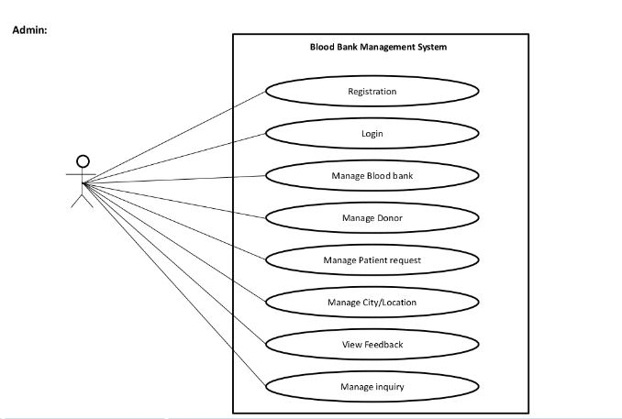

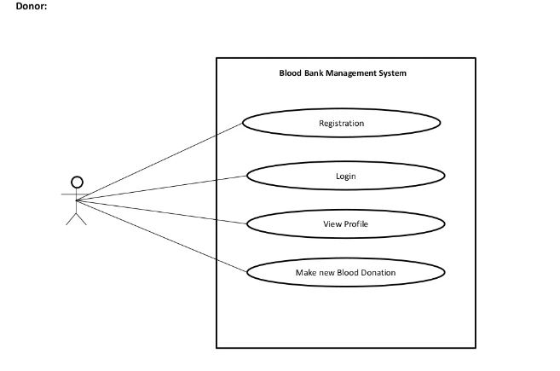

Figure 2: Use case Diagram

**Non-Functional Requirements**

**The Non-Functional Requirements of the project are as follows:**

* The system should be reliable and robust.
* The system should be User friendly.
* The system should be completely Consistent and Secure.

### Feasibility Analysis

The feasibility study of any system is mainly intended to study and analyze the proposed system and to decide whether the system under consideration will be viable or not after implementation. That is, it determines the usability of the project after deployment. To come to result a set of queries is answered keeping the efficiency of the software and its impact on the domain for which it was developed . Its main emphasis is on the following three questions elucidated below as:

What are the user’s requirements and how does a candidate system meet them?

What resources are available for the proposed systems? Is it worth solving the problem?

What is the likely impact of the proposed system on the organization? I.e. how does the proposed system fit within the organization?

Thus since the feasibility study may lead to commitment of large resources, it becomes necessary that it should be conducted competently and no fundamental errors of judgment are made. Different types of feasibility study and the way we performed on our project “Chatting Application**”**.

**Technical Feasibility**

In technical feasibility, we study all technical issues regarding the proposed system. It is mainly concerned with the specifications of the equipment and the software, which successfully satisfies the end-user’s requirement. The technical needs of the system may vary accordingly but include:

* The feasibility to produce outputs in a given time.
* Response time under certain conditions.
* Ability to process a certain volume of the transaction at a particular speed.
* Facility to communicate data.

**Economic Feasibility**

Are there sufficient benefits in creating the system to make the acceptable? Or are the costs of not creating the system so great that it is advisable to undertaken the project.

This will include three major costs as described below:

* Cost of Hardware and Software
* Cost of Software to be acquired to build and run the product is a onetime cost.
* Buying a back and database is the major part of hardware and Software cost. Comparison between the oracle database high cost and better features with the SQL server low cost and better support for the same vendor operating system make this decision need oriented.

Benefits in reduced cost, error and saving will be made by reduction of present system expenses, time saving and increased accuracy.

Cost Avoidance:

Future cost reduction in form of reduction in the number of administrative staff needed and manual records maintains in organization. Rise in cost will be avoided.

**Operational Feasibility**

All the functions of the system are possible to create. The system’s user platform is for those interested in books of all types. The system can be operated by anyone without the advanced knowledge about the system. This website is easy to use and can be operated by anyone.

**Schedule Feasibility**

Our project is based on the time schedule that we had planned for it to be completed in a sequential way. For the detail information,

We managed to define project, deliver our report (Proposal) and got approved on 2nd week of baishak.

Secondly, we started working on System analysis, gathering system requirements, tools and technologies on the 3rd to 4th week of baishak.

Thirdly, we managed to design the overview of our project on 1st week of zetha. Similarly, on 2nd and 3rd week we worked in High level diagrams for our project base.

On fourth stage of our project, we started coding whole month on ashar.

Likewise, we tested our project with the help of our project consultant/supervisor and reworked till 1st week of shrawn and we delivered report in the 2nd week of shrawn.

And for reassuring we tested our project again for long time on 3rd week of shrawn so that we can still update before final report.

Finally, we submitted our final documentation. However,

## Data Modeling (ER Diagram)

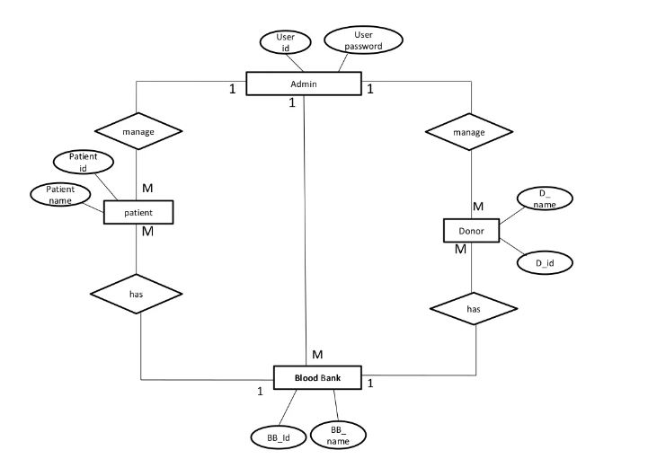

Figure 3: ER Diagram

## Process Modeling

### Data Flow Diagram (DFD)

This diagram is the representation of the system flow chart. It provides all the required knowledge regarding the following system that is to be encoded. DFDs can be used to analyze an existing system or model a new one. Like all the best diagrams and charts, a DFD can often visually “say” things that would be hard to explain in words, and they work for both technical and nontechnical audiences, from developer to CEO. That’s why DFDs remain so popular after all these years. While they work well for data flow software and systems, they are less applicable nowadays to visualizing interactive, real-time or database-oriented software or systems .

There are two specific system to represent the Data Flow Diagram model specified with the names of people who first created it;

| Notation | Yourdon and Coad | Gane and Sarson |
| --- | --- | --- |
| External Entity |  |  |
| Process |  |  |
| Data Store |  |  |
| Data Flow |  |  |

**Context Diagram**

This diagram represents what are the bounders and scope of **Blood Bank Management** project. It describes the main objective of the system and its entities involved.

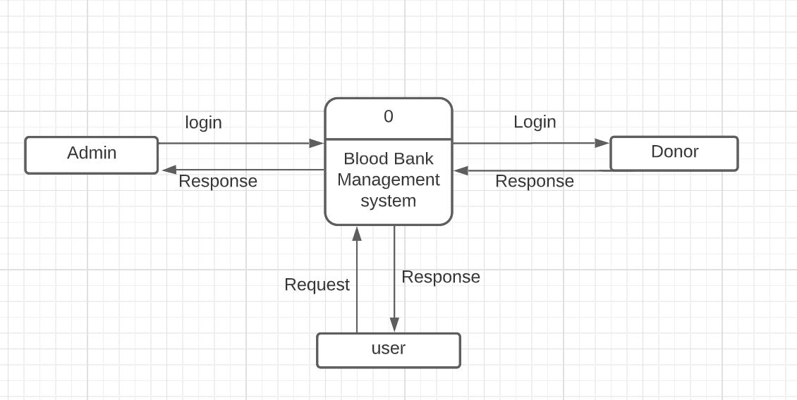

Figure 4: the context diagram

**The Administrator can do the following**

* Manage and Update data.
* System maintenance.

**The donor can do the following**

* Login and register.
* donate Blood.
* View and Edit Profile.

**The Recipient can do the following**

* Login and register.
* Request for Blood.

**Zero (0) Level Diagram**

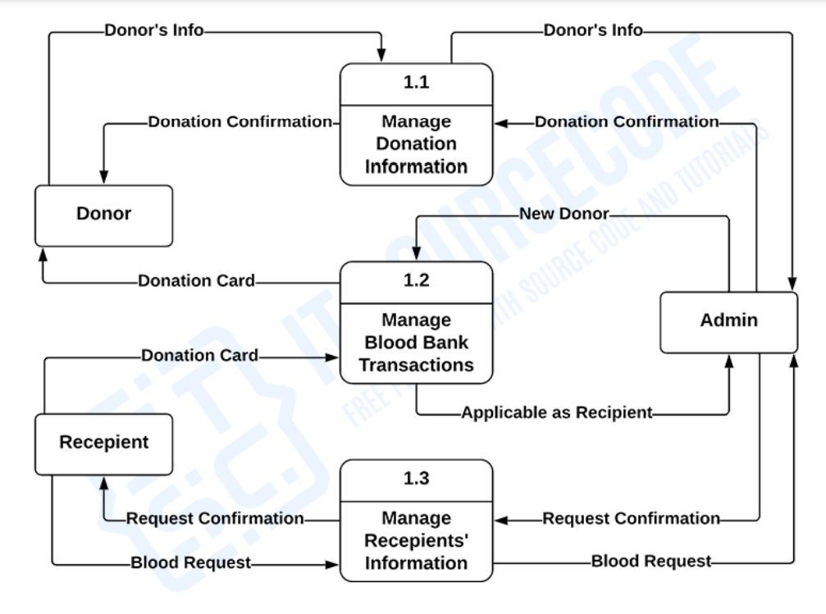

Figure 5: 0-level DFD

### 3.4 Data Flow Diagram (DFD)

### 3.4.1 Database schema Design

### 

# 3.4.2 Interface Design

**home page**

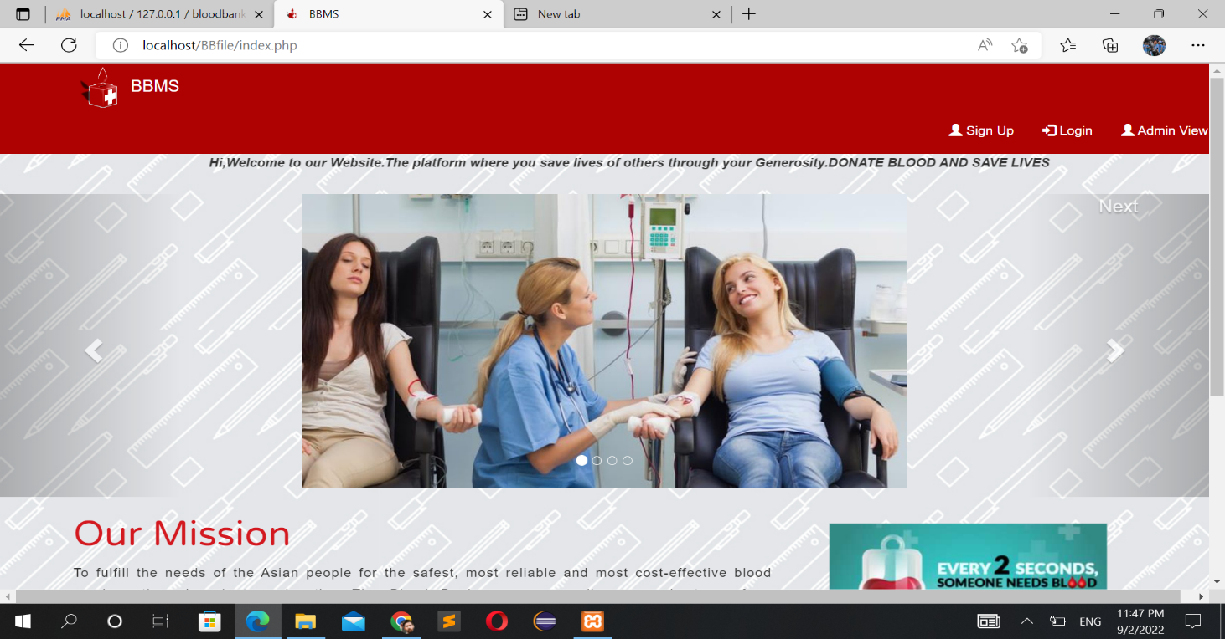

**Admin login Form**

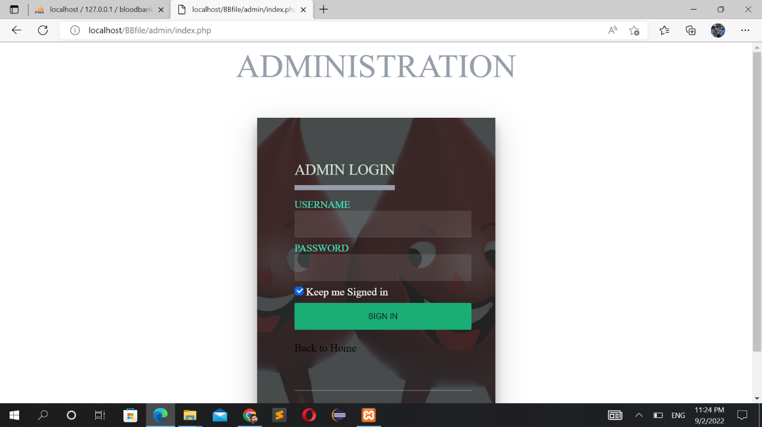

**Admin Dashboard**

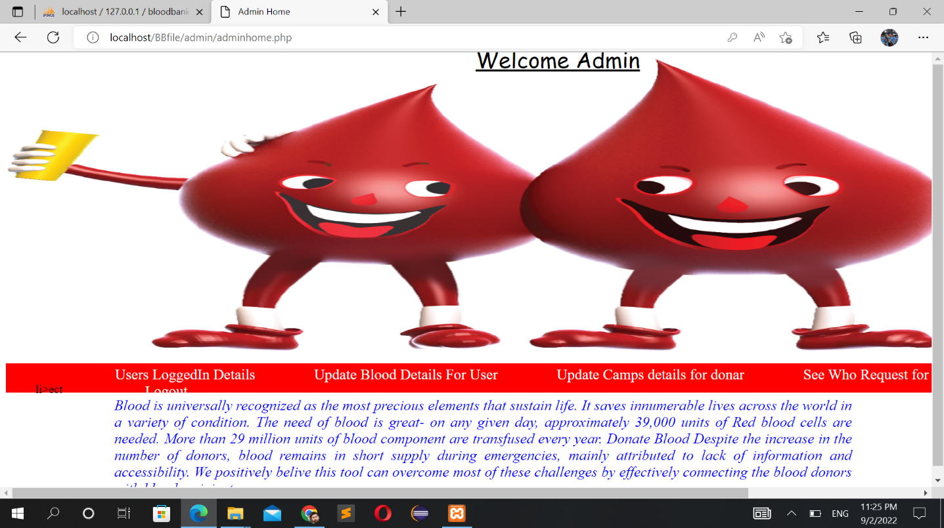

**Total blood**

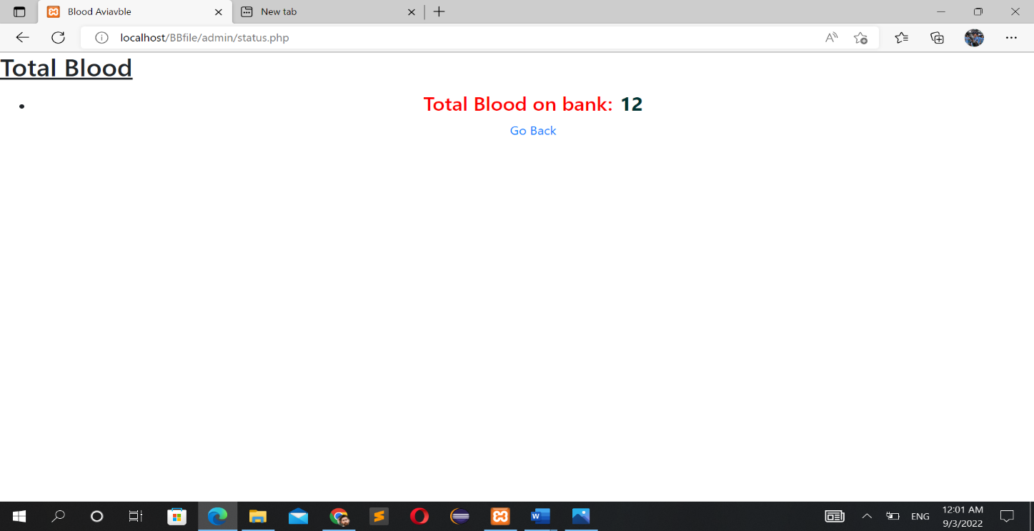

**User Registration Form**

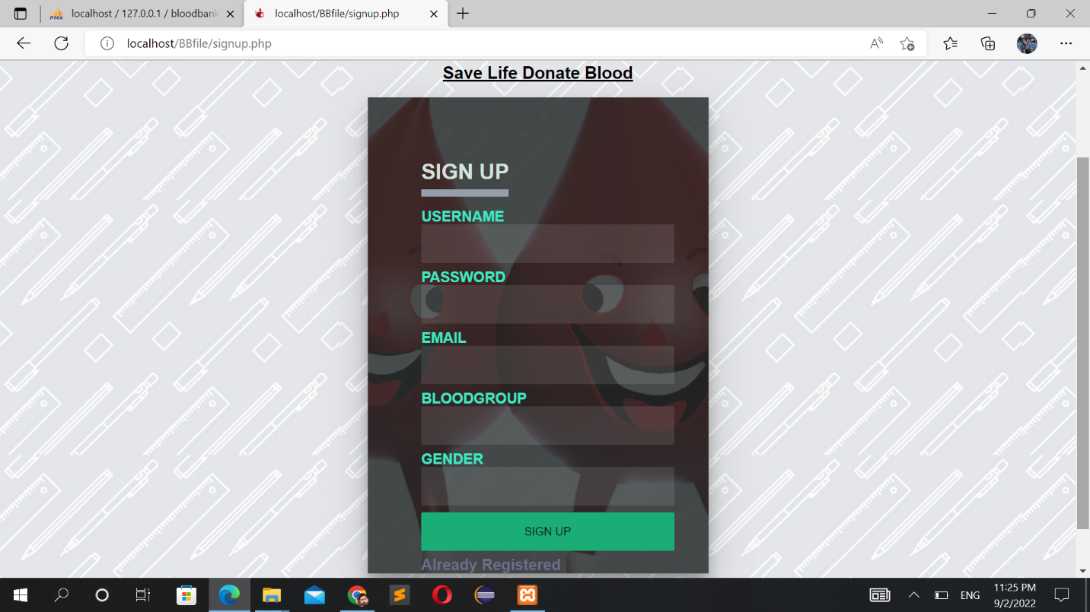

**User login**

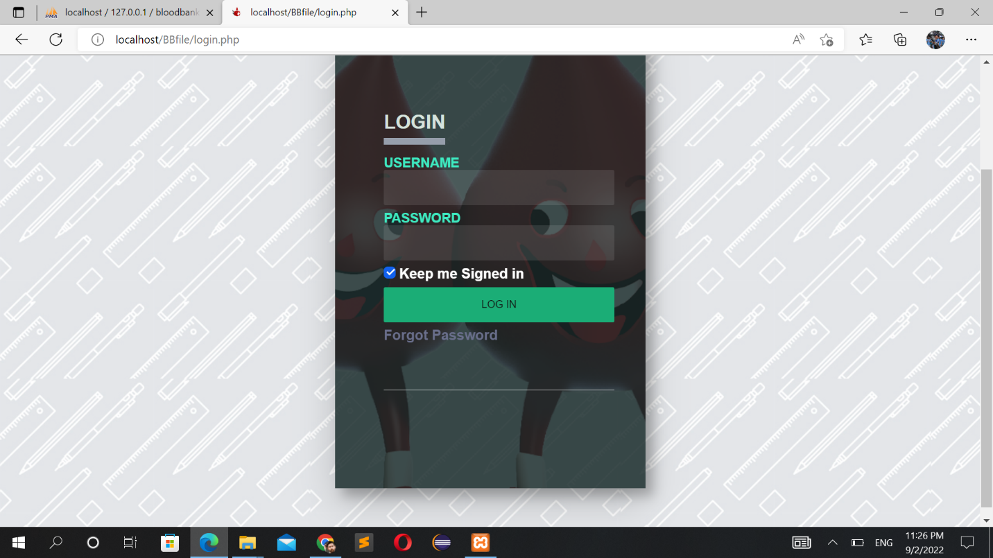

**Admin Dashboard**

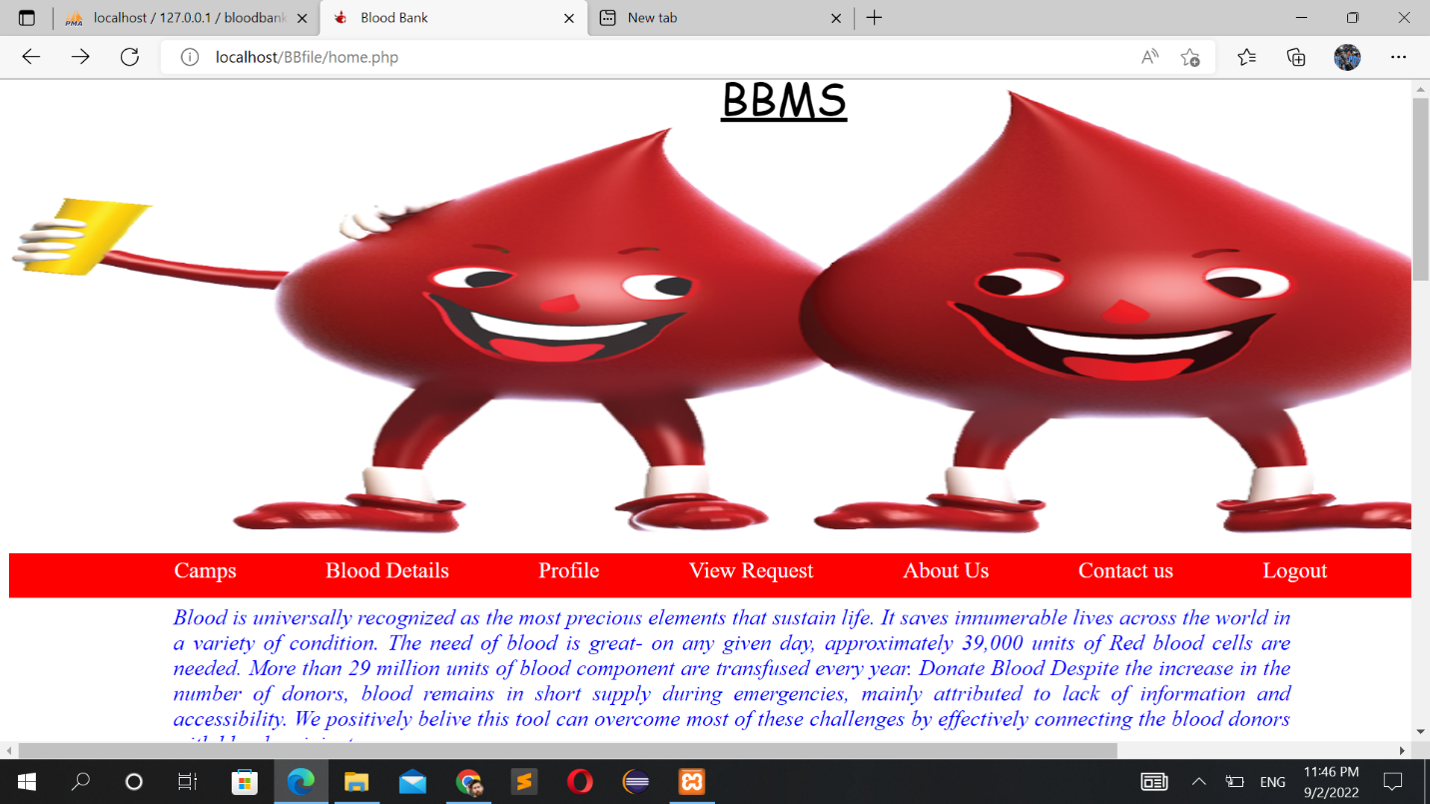

**Blood details**

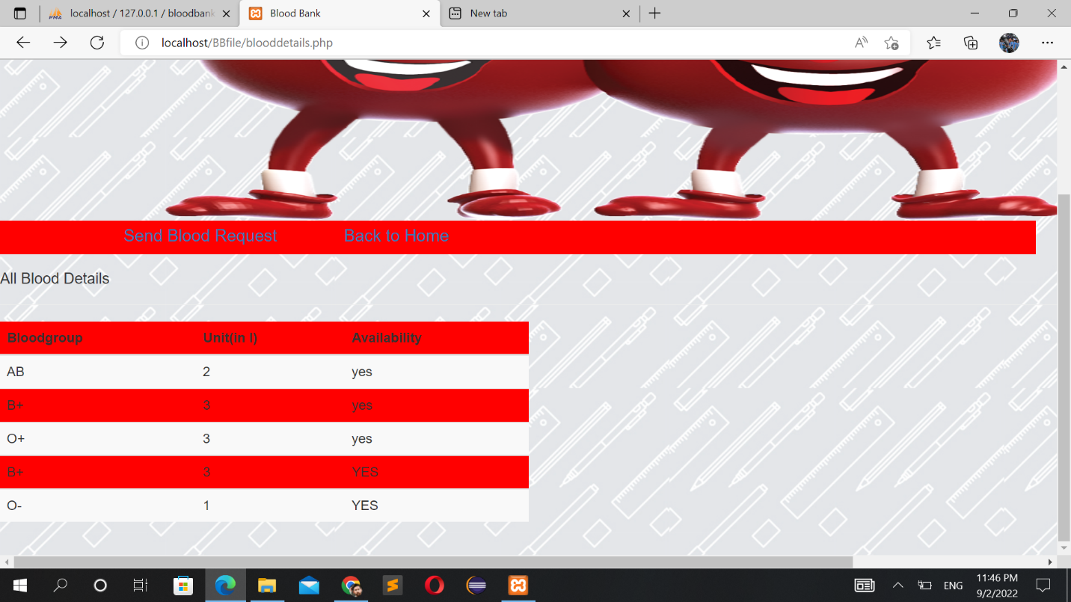

**Send Blood Request**

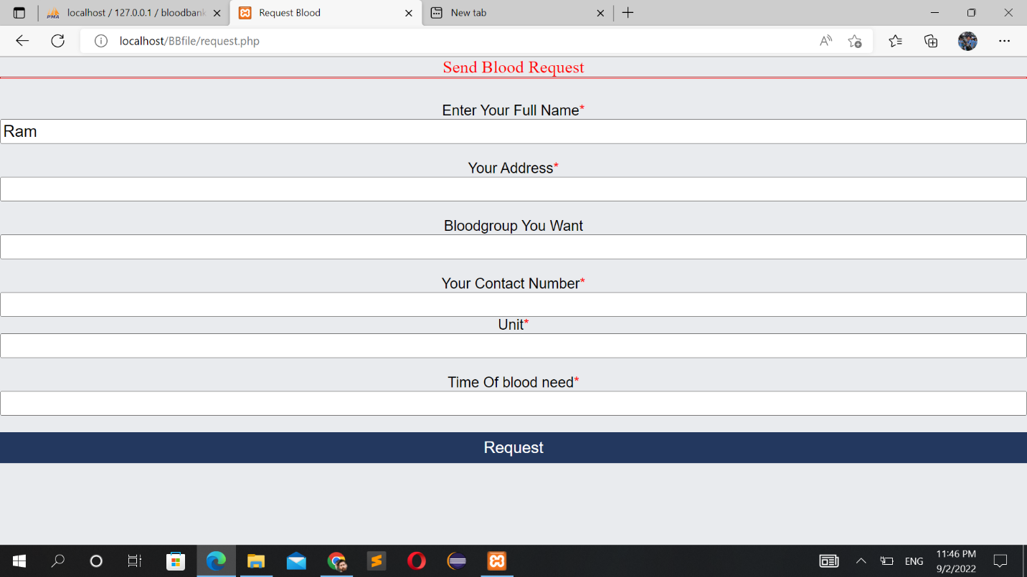

**User Profile**

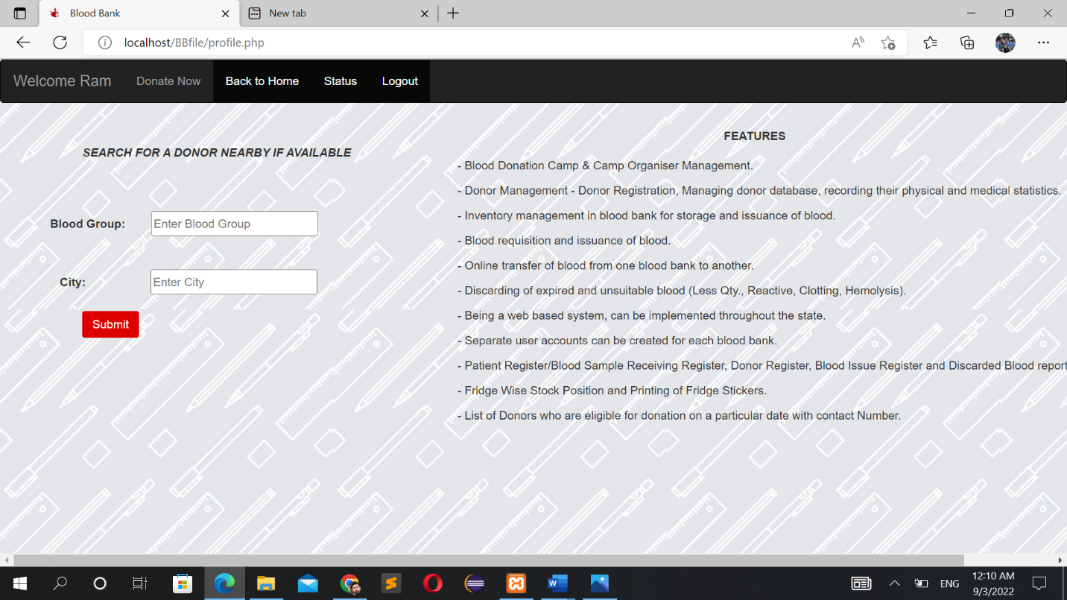

**Blood Donate**

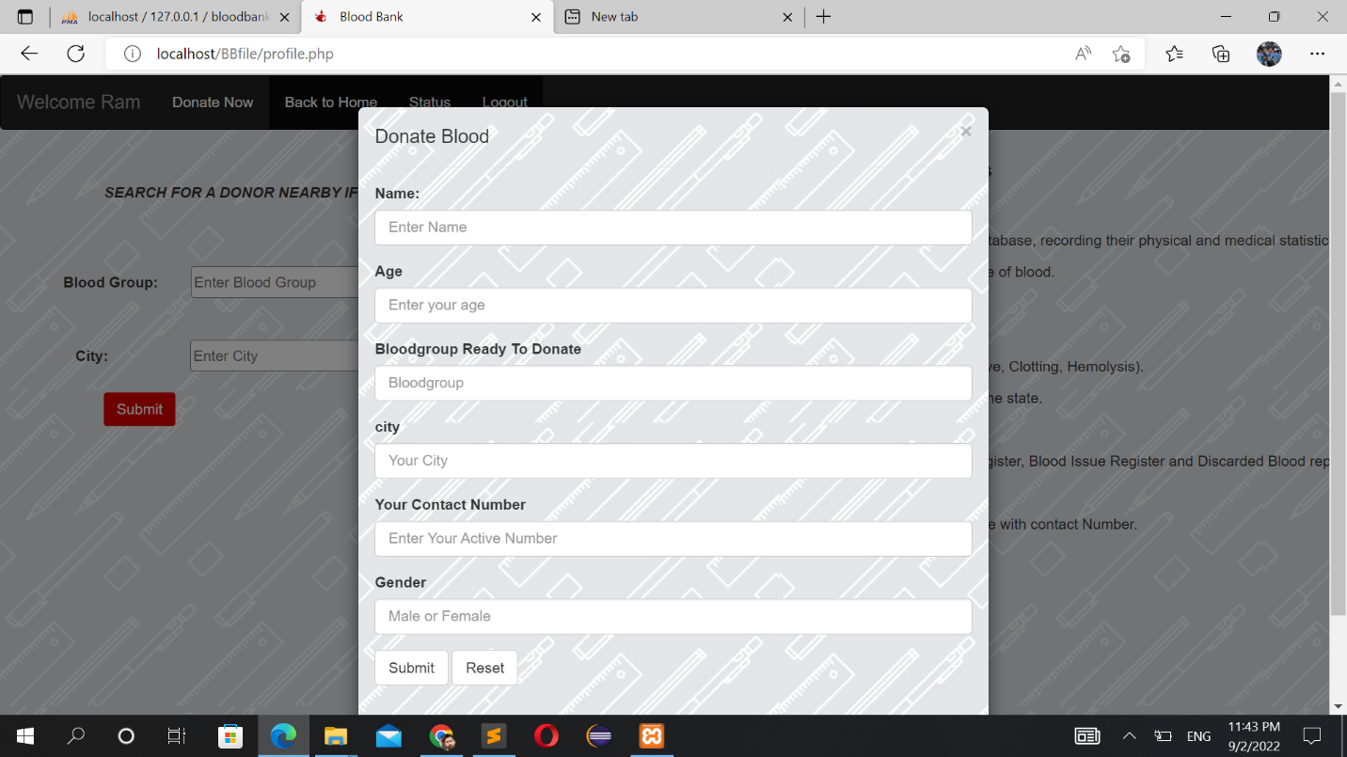

**Blood Request**

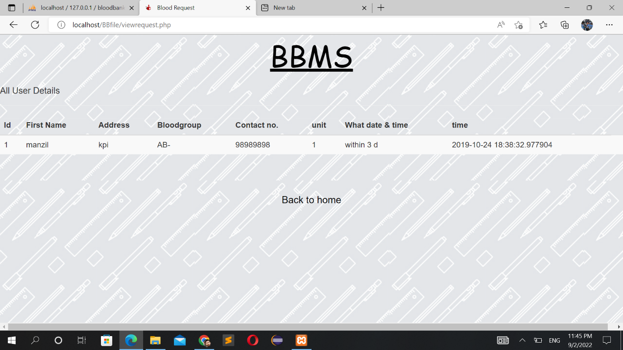

# 3.5 Algorithm

# Searching Algorithm:

# In this system I have implemented a searching algorithm which step are show below.

Syntax Algorithm:

step 1: start

step 2: set a [5]

step 3: set i<0

step 4: Input searching item

step 5: Repeat step 6 and 7 while i<5

step 6: if a[i]= item then print item found and then found location= I &e exit

step 7; i < i+1

step 8: If i >=then print item not found

step 9: End

# Chapter 4

# Implementation and Testing

## Implementation

### Tools Used (CASE tools, Programming language, Database platform)

**Front End:**

Front-End Development is done with following development tool: -

HTML: HTML is a markup language use for creating web pages. A structure document like heading, paragraph, list, link, and other items using html have done for this project.

CSS: This CSS helps us to make our documentation attractive using different tools, using colors.

**Back End:**

PHP: Over all backend programming has been done with PHP.

MySQL: All data storing in database, order details, price calculation is all related with MySQL.

### Implementation Details of Modules (Description of procedure and functions)

Chatting Application is a convenient means to communicate with the people you know in a real time. The modules make the maintenance of database easier . Two modules are used for this project which are listed below:

**Admin module:**

This module provides functionality for the power Administrator only. It will not be available to any other users of the system. This module will allow an Admin to manage the administrator control and users details and can also delete the whole data.

* Log in to the system.
* “Admin” option: allows to Add/update/delete/view.

**User’s module:**

* log in to the system.
* user can donate the blood.
* user can request the blood.

## Testing

Testing is the practice of making objective judgments regarding the extent to which the system (device) meets, exceeds or fails to meet stated objective. A project may fail without a complete Test Plan. Test planning is particularly important in any software system development. So, in order to test the customer module and admin module in this project following test cases are created then these test cases are executed to check the correctness of the system.

### 4.2.1. Test Case of Unit Testing

A unit testing is the smallest testable part of software. It usually has one or few inputs and usually a single output. Unit testing is a software development process in which the smallest testable parts of an application called units are individually and independently checked for proper operations. Unit testing increases confidence in changing and maintaining code. Each module has been tested in an attempt to discover any error in the code.

**Admin module**

|  |  |  |  |  |  |
| --- | --- | --- | --- | --- | --- |
| S.N | Test Cases | Objective | Input Data | Expected Outcome | Remark |
| 1 | Login Page | To check login functionality with invalid password and invalid username | Username: XXX  Password: XXX | Error message will be display  Username or Password did not match. | Fail |
| 2 | Login Page | To check login functionality with valid password and valid username | Username: admin  Password: admin@123 | Admin should login successfully and message will be display Login Successful | Pass |
| 3 | Login Page | To check login functionality with invalid password and valid username | Username: admin  Password: XXX | Error message will be display  Username or Password did not match | Fail |
| 4 | Login Page | To check login functionality with valid password and invalid username | Username: XXX  Password: admin@123 | Error message will be display  Username or Password did not match | Fail |
| 3 | Manage Admin | To add admin | Adds username, email, password | Was added successfully message. | Pass |
| 4 | Update  Admin | To update admin | Updates username, email, password | Was updated successfully message. | Pass |
| 5 | Delete  Admin | To delete admin | Deletes username, email, password | Was deleted successfully message. | Pass |
| 6 | Manage User | Add, Update & Delete | Manipulate and changes the data and information existed in database. | Was added, updated & deleted successfully message. | Pass |

**Donor modules**

|  |  |  |  |  |  |
| --- | --- | --- | --- | --- | --- |
| S.N | Test Cases | Objective | Input Data | Expected Output | Remark |
| 1 | Register | To get logged in. | Username: Ram Shrestha  Email: user  Password: user@123 | Email is not valid. | Fail |
| 2 | Register | To get logged in. | Username: Ram Shrestha  Email: user@gmail.com  Password: user@123 | Successfully registered. | Pass |
| 3 | Login | To start conversation | Email: user@gmail.com  Password: user@123 | Successfully logged in. | Pass |
| 4 | Donate | To Donate Blood | submit | Successfully | pass |
| 4 | Request | To request for blood | request | Sent successfully. | Pass |
| 5 | View Profile | To check profile details | Profile is viewed | Details of user profile | Pass |

*Note: For each testing we need to be logged in with respective email if we don’t have access to login page, we must register ourselves to get logged in into the system.*

### Test Case for System Testing

System testing is performed on the entire system it works perfectly with no error. So, after this testing we assume the design and behavior of the system meets our expectation. That’s why this project is placed for submission.

# Chapter 5

# Outcome and Conclusion

## Lesson Learn / Outcome

After the completion of this project following outputs are expected which will minimize the problems as well as solve the existing problem.

* Clean and informative interface with easy user experience
* Secure donor privacy and encrypted password system
* Informative and accurate search results
* Expected to provide better services.

## Conclusion

Technology is introducing new innovations every day, thus the time required to do things is reducing day by day. The proposed Website can be used to reduce the time required to deliver required blood to the needy in cases of emergency. The Website can be used by the individuals interested in donating their blood by locating their nearest blood bank. The main focus of this project is to less in human effort. The maintenance of the record is made efficient, as all the record are stored in the SQL database. It is user interactive and effective than the existing system. The flexibility of visual basic helps to maintain the "Blood Bank management system" more efficiently.

# Reference

[1] <https://www.slideshare.net/RajendraPrasad361/blood-bank-management-system-94381134>

[2]<https://www.google.com/search?q=dfd+of+blood+bank+management+system&sxsrf=ALiCzsZio4fnwWqzGAcm8gmmUQQF8kbK5Q>

[3]<https://www.google.com/search?q=Blood+Bank+Management+System+documentation&oq=blo&aqs=chrome>

[4] <https://www.academia.edu/33737141/Blood_Bank_Management_System>

[5]<https://www.google.com/search?q=introduction+of+blood+donation+management+system&oq=intro&aqs=chrome>

a blood bank known as blood collection center, also is an area in which

collected blood bags are stored and preserved for future use in blood transfusion services. Blood

transfusion is a medical operation where a patient requires blood or blood products as a life

saving measure. In a report by Ministry of Health(MoH) in its website, it mentioned that the total

amount of blood donated annually in Muscat is approximately 25,084 units. MoH further

reported that its Department of Blood Services is functioning at full capacity to meet the

demands in the Sultanate.

Most blood banks are still running manual system in its processes. As such, there is a lack of

efficiency because it is still paper-based in collecting information about donors, inventories of

blood bags, and blood transfusion services. The lack of proper documentation may endanger

patients’ health due to the possibility of having contaminate blood bags. Contamination happened

when there is an incomplete donors’ medical history record and the blood bags’ shelf life is not

monitored properly. Hence, a web-based blood bank management system might be needed to

address these issues and problems encountered to ensure blood transfusion safety.

a blood bank known as blood collection center, also is an area in which

collected blood bags are stored and preserved for future use in blood transfusion services. Blood

transfusion is a medical operation where a patient requires blood or blood products as a life

saving measure. In a report by Ministry of Health(MoH) in its website, it mentioned that the total

amount of blood donated annually in Muscat is approximately 25,084 units. MoH further

reported that its Department of Blood Services is functioning at full capacity to meet the

demands in the Sultanate.

Most blood banks are still running manual system in its processes. As such, there is a lack of

efficiency because it is still paper-based in collecting information about donors, inventories of

blood bags, and blood transfusion services. The lack of proper documentation may endanger

patients’ health due to the possibility of having contaminate blood bags. Contamination happened

when there is an incomplete donors’ medical history record and the blood bags’ shelf life is not

monitored properly. Hence, a web-based blood bank management system might be needed to

address these issues and problems encountered to ensure blood transfusion safety.

.